Staunton Harold Sailability Trust

Hereford Hoist user instructions

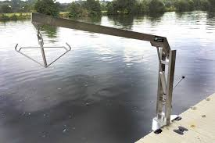
Safe operation requires two people
- The hoist must be located in the mounting provided on the pontoon, check it is secure and rotate the hoist arm fully to check free movement.
- Check the hanger attachment is fitted correctly on the end of the arm.
- Check the piston ensuring it is clean and free of dirt and there is no oil leaks.
- The arm is raised and lowered by hydraulic pressure, there is a valve on the cylinder that controls the speed of lowering, and a handle that pumps up the pressure raising the arm.
- To lower the arm, release the valve by turning anti clockwise till you arrive at the desired height then close by turning clockwise to finger tight.
- To raise the arm the valve must be closed then using the handle pump the are up till it reaches the desired height, only raise it to the height required.
- To move the hoist into the correct position for lifting or lowering rotate the whole hoist by pushing using the hoist arm.
- When using the sling ensure that it is fully around the person being lifted and cross the handles before attaching to the hoist handle.
- Raise the person until at the desired height over the pontoon before swinging them over to the boat.

